Schedule 2 – Services for which money is appropriated
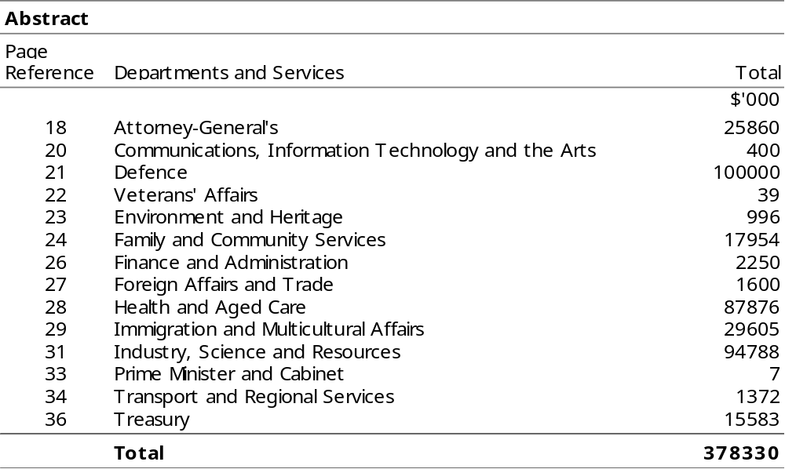Note: See Sections 6 and 15

DEPARTMENTS AND SERVICES

Summary
Additional Appropriation (bold figures) – 2000-2001
Budget Appropriation (italic figures) – 2000-2001
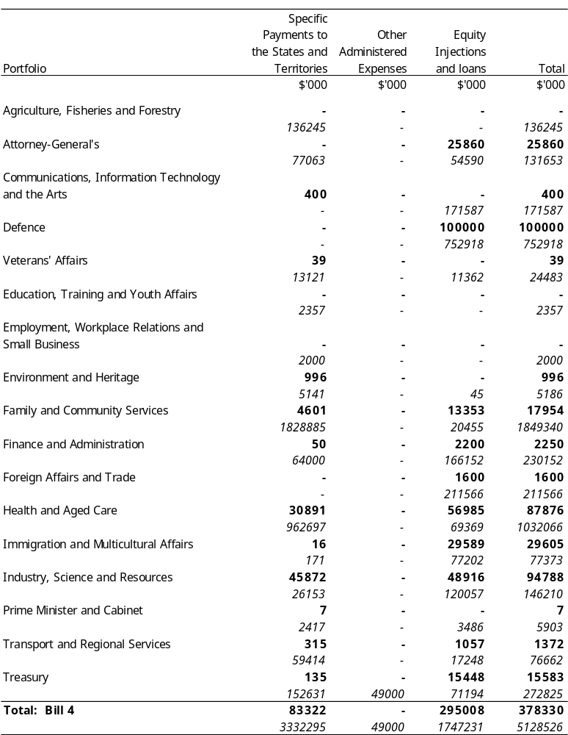
Title
Additional Appropriation (bold figures) – 2000-2001
Budget Appropriation (italic figures) – 2000-2001
Actual Available Appropriation (light figures) – 1999-2000
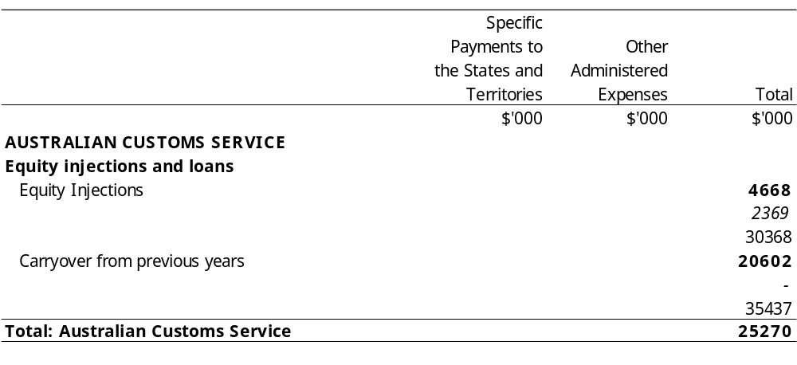
Title
Additional Appropriation (bold figures) – 2000-2001
Budget Appropriation (italic figures) – 2000-2001
Actual Available Appropriation (light figures) – 1999-2000
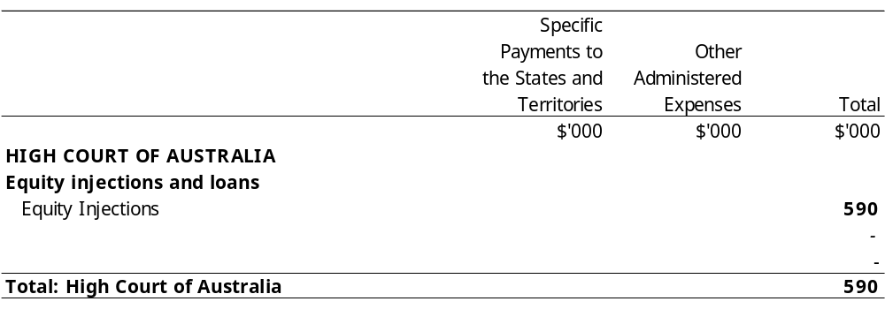
Title
Additional Appropriation (bold figures) – 2000-2001
Budget Appropriation (italic figures) – 2000-2001
Actual Available Appropriation (light figures) – 1999-2000
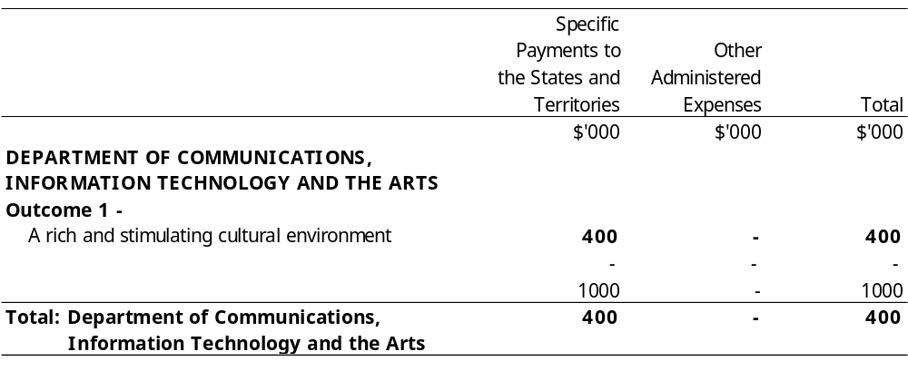
Title
Additional Appropriation (bold figures) – 2000-2001
Budget Appropriation (italic figures) – 2000-2001
Actual Available Appropriation (light figures) – 1999-2000
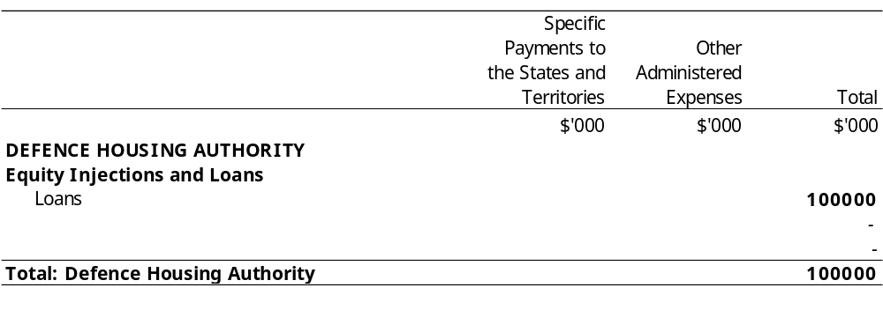
Title
Additional Appropriation (bold figures) – 2000-2001
Budget Appropriation (italic figures) – 2000-2001
Actual Available Appropriation (light figures) – 1999-2000
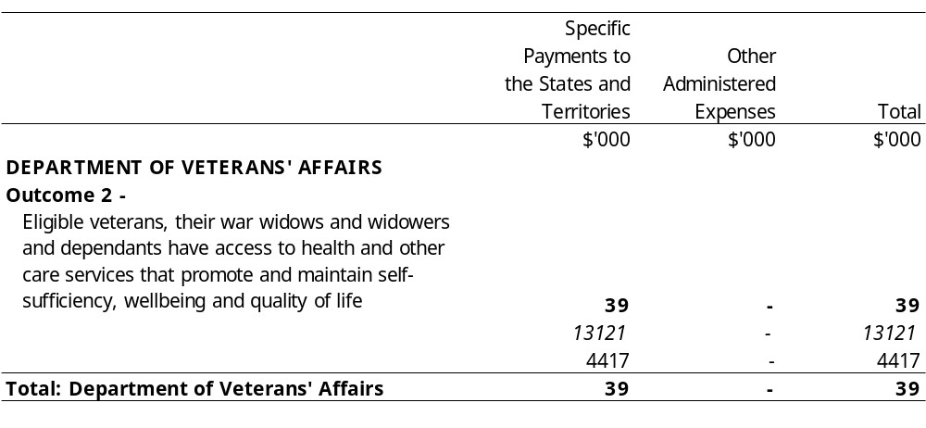
Title
Additional Appropriation (bold figures) – 2000-2001
Budget Appropriation (italic figures) – 2000-2001
Actual Available Appropriation (light figures) – 1999-2000
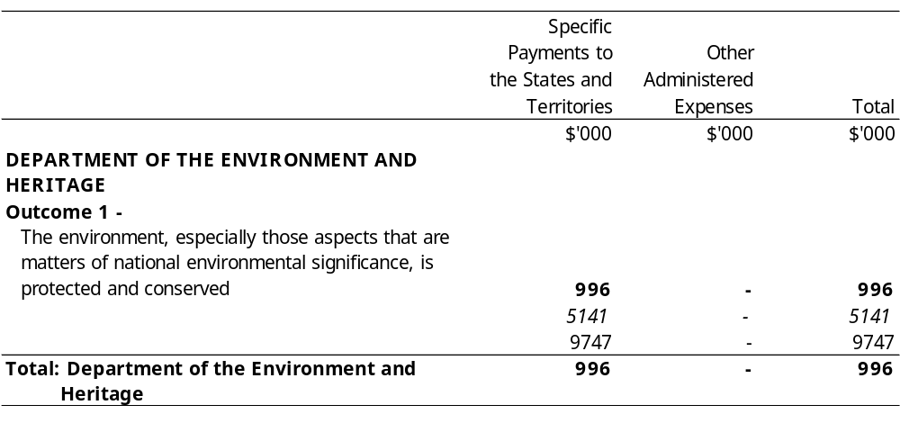
Title
Additional Appropriation (bold figures) – 2000-2001
Budget Appropriation (italic figures) – 2000-2001
Actual Available Appropriation (light figures) – 1999-2000
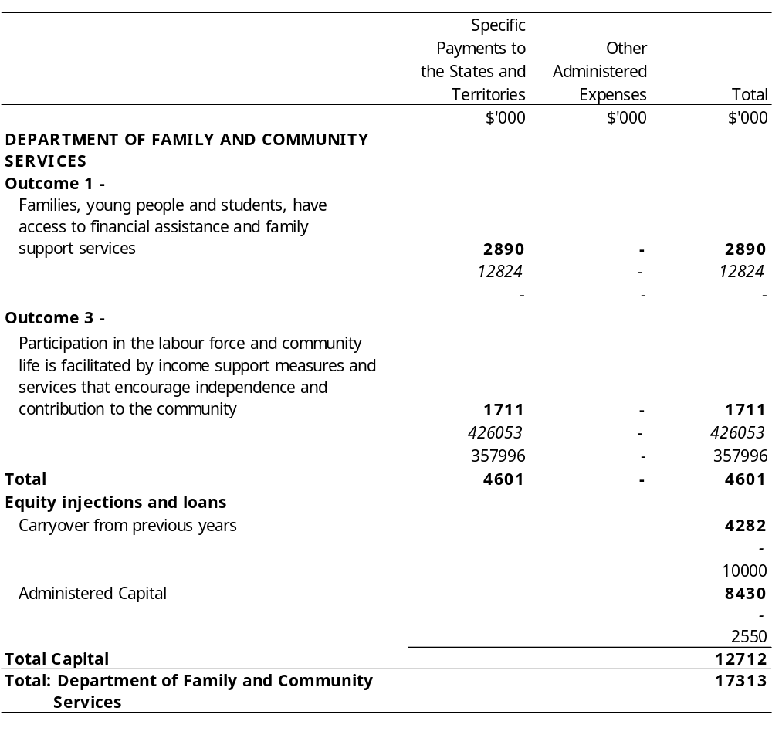
Title
Additional Appropriation (bold figures) – 2000-2001
Budget Appropriation (italic figures) – 2000-2001
Actual Available Appropriation (light figures) – 1999-2000
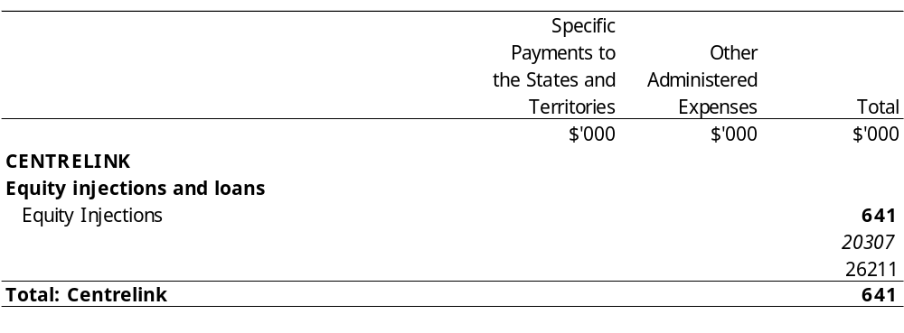
Title
Additional Appropriation (bold figures) – 2000-2001
Budget Appropriation (italic figures) – 2000-2001
Actual Available Appropriation (light figures) – 1999-2000
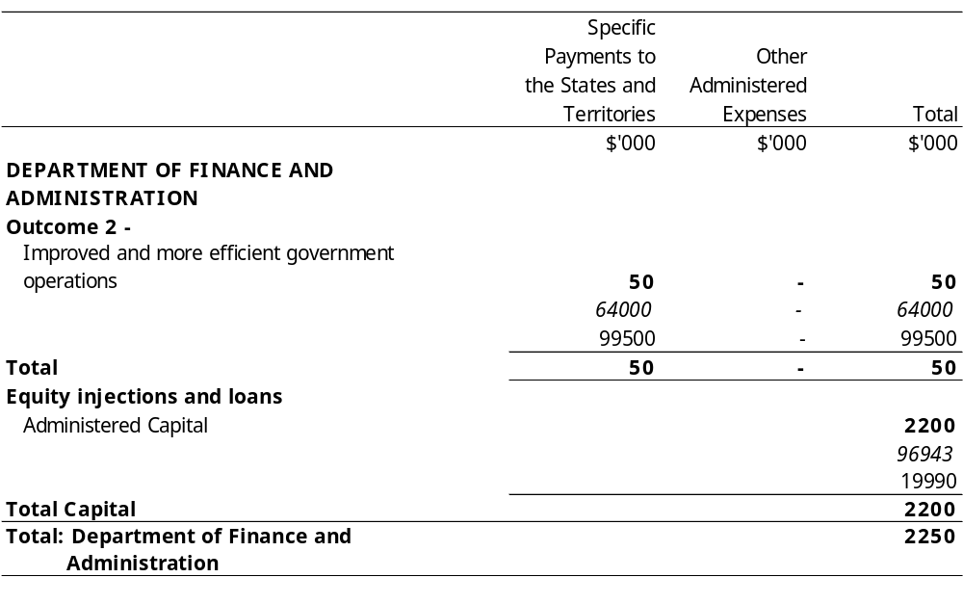
Title
Additional Appropriation (bold figures) – 2000-2001
Budget Appropriation (italic figures) – 2000-2001
Actual Available Appropriation (light figures) – 1999-2000
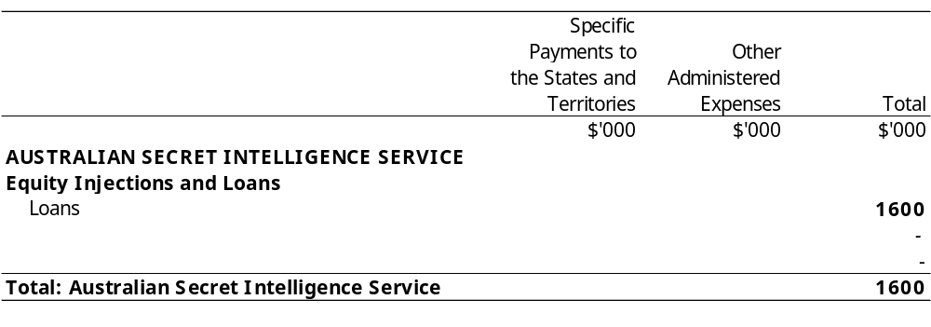
Title
Additional Appropriation (bold figures) – 2000-2001
Budget Appropriation (italic figures) – 2000-2001
Actual Available Appropriation (light figures) – 1999-2000
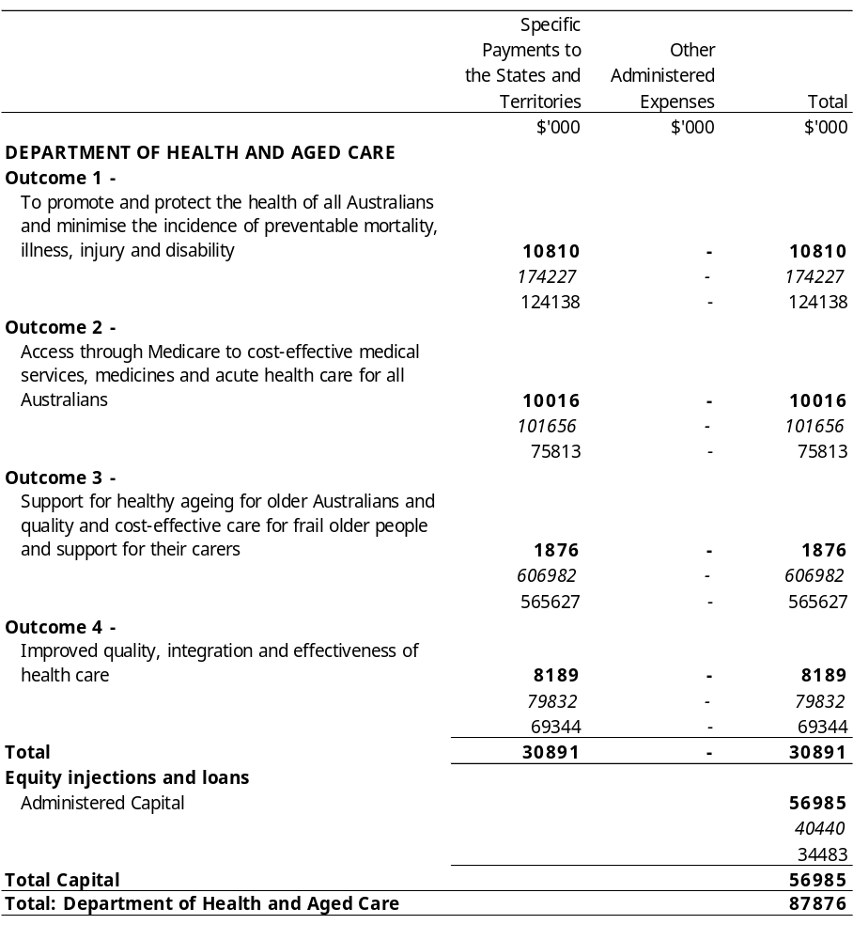
Title
Additional Appropriation (bold figures) – 2000-2001
Budget Appropriation (italic figures) – 2000-2001
Actual Available Appropriation (light figures) – 1999-2000
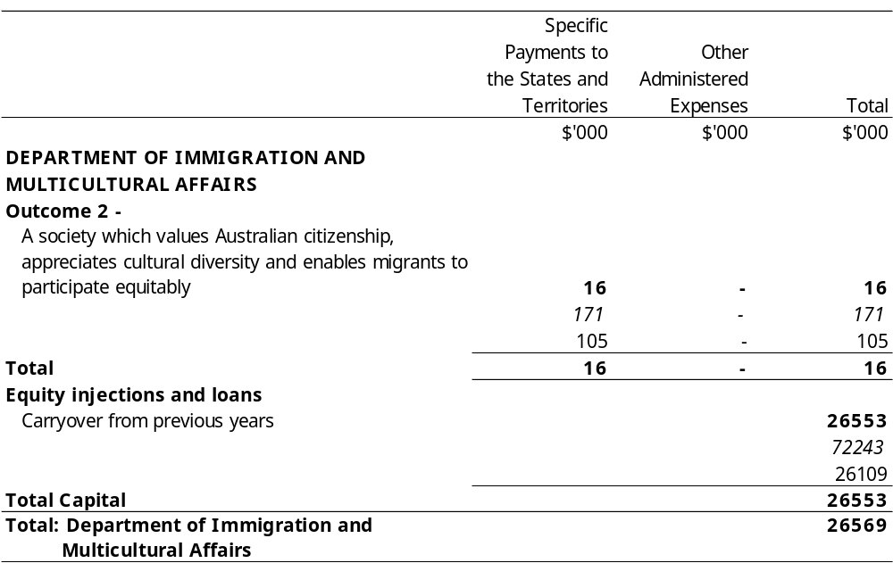
Title
Additional Appropriation (bold figures) – 2000-2001
Budget Appropriation (italic figures) – 2000-2001
Actual Available Appropriation (light figures) – 1999-2000
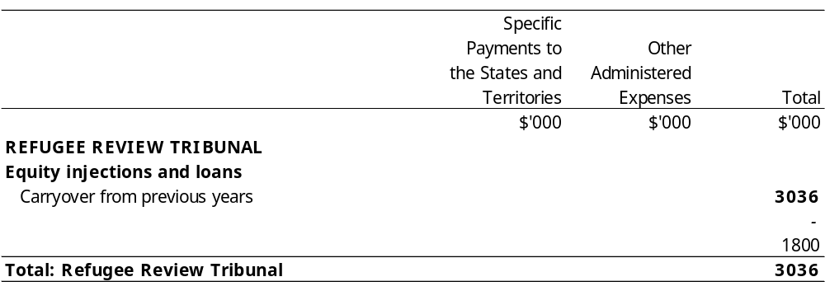
Title
Additional Appropriation (bold figures) – 2000-2001
Budget Appropriation (italic figures) – 2000-2001
Actual Available Appropriation (light figures) – 1999-2000
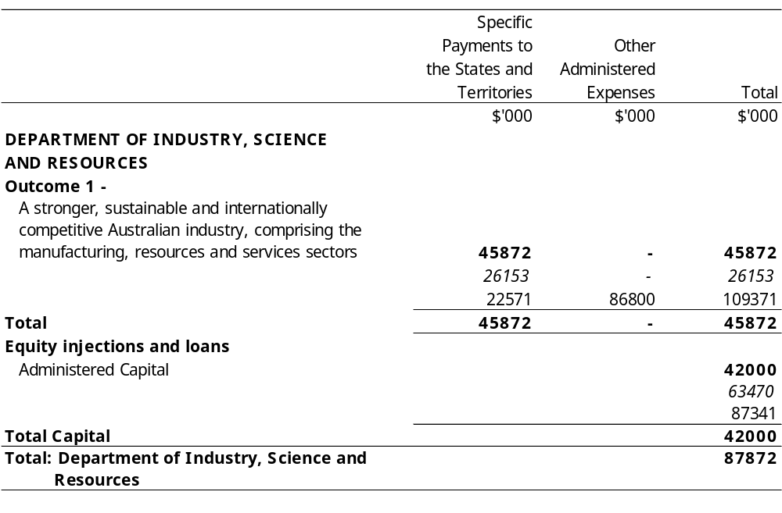
Title
Additional Appropriation (bold figures) – 2000-2001
Budget Appropriation (italic figures) – 2000-2001
Actual Available Appropriation (light figures) – 1999-2000
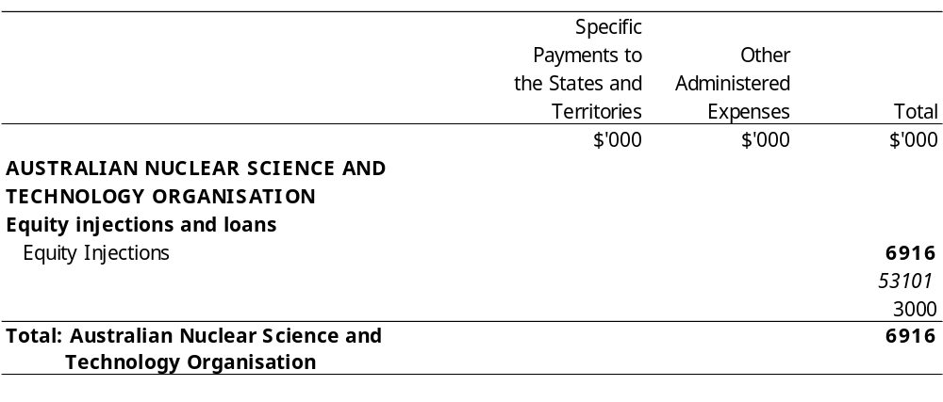
Title
Additional Appropriation (bold figures) – 2000-2001
Budget Appropriation (italic figures) – 2000-2001
Actual Available Appropriation (light figures) – 1999-2000
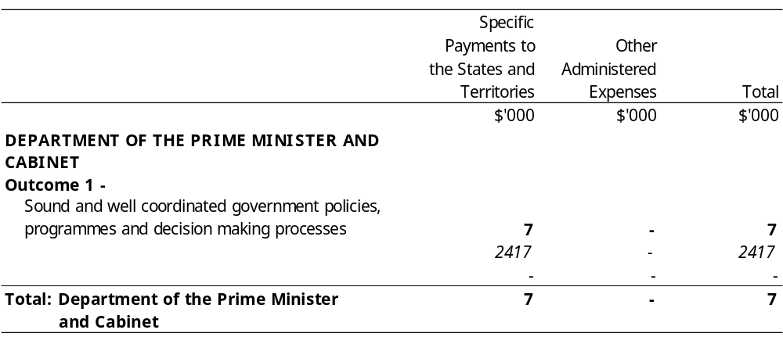
Title
Additional Appropriation (bold figures) – 2000-2001
Budget Appropriation (italic figures) – 2000-2001
Actual Available Appropriation (light figures) – 1999-2000
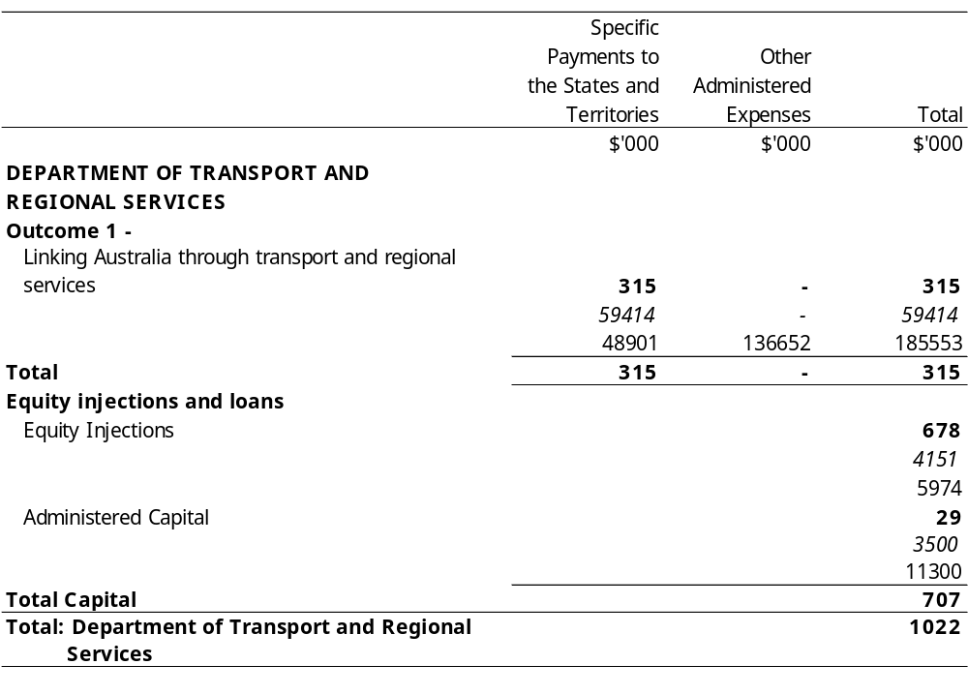
Title
Additional Appropriation (bold figures) – 2000-2001
Budget Appropriation (italic figures) – 2000-2001
Actual Available Appropriation (light figures) – 1999-2000
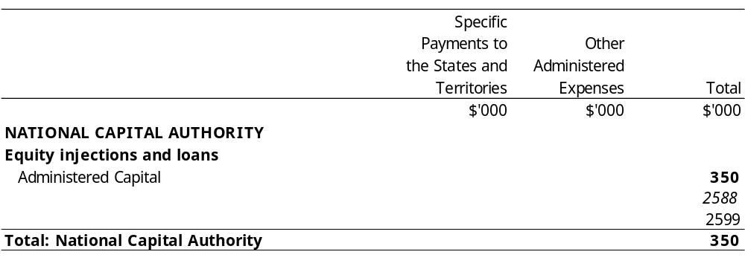
Title
Additional Appropriation (bold figures) – 2000-2001
Budget Appropriation (italic figures) – 2000-2001
Actual Available Appropriation (light figures) – 1999-2000
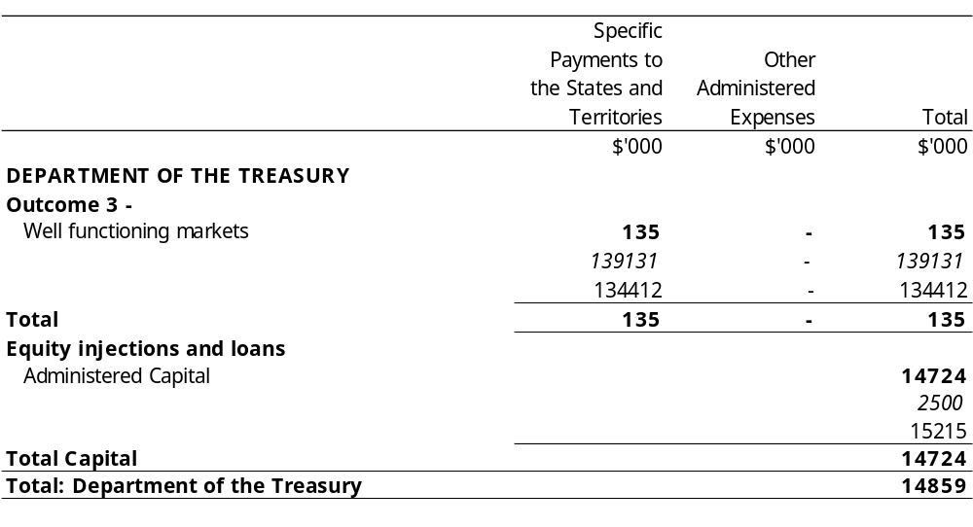
Title
Additional Appropriation (bold figures) – 2000-2001
Budget Appropriation (italic figures) – 2000-2001
Actual Available Appropriation (light figures) – 1999-2000
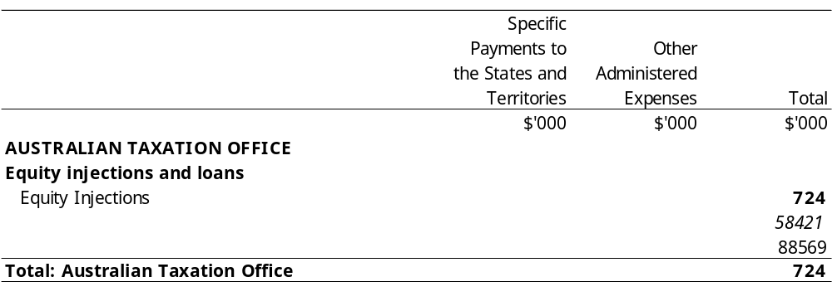

[Minister’s second reading speech made in—
House of Representatives on 29 November 2000
Senate on 26 March 2001]

(182/99)

